UNEP-DTU Partnership, World Resources Institute

Transformational Change Guidance
Guidance for assessing the transformational impacts of policies and actions
January 2021
Assessment template

This assessment template is provided to help users apply the Transformational Change Guidance. It contains the key recommendations for reporting from Chapter 11. It also includes the key assessment tables from the guidance, which can be filled out directly. Users can consult the Transformational Change Guidance while using this template for information about how to carry out the steps. The template presents one way of documenting the recommended information. Users may record their assessment results in any format considered most useful to the intended audience.

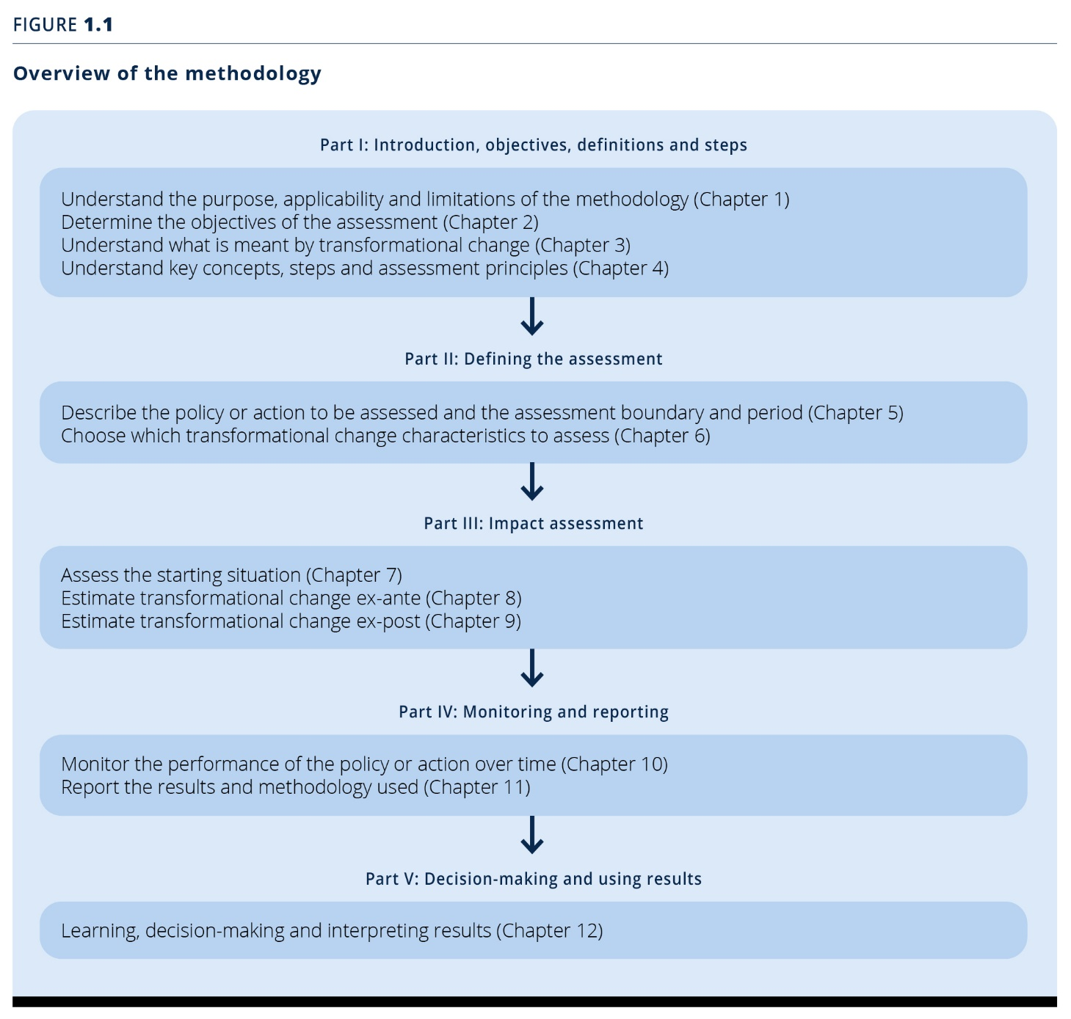
Overview of the Methodology
Not all steps of the guidance require actions by the user when assessing the transformational impact of a policy. The following template focuses only on those steps that do.

Defining the Assessment (Part I & II)

General information on the policy/action/package assessed
General information
- Name the policy or action, or package of policies and/or actions, assessed
- Provide author, date, and type of assessment
Objectives of assessing transformational change (Chapter 2)
- Determine the objective(s) of the assessment
- Determine the intended audience(s) of the assessment
Steps and assessment principles (Chapter 4)
- Determine opportunities for stakeholders to participate in the assessment
(Section 4.2.2)
- List the principles on which the assessment is based
(Section 4.3)
General information | Assessment information
Name of the policy/action/package assessed
Person(s)/organisation(s) that did the assessment
Date of the assessment
Whether the assessment is an update of a previous assessment, and if so, links to any previous assessments
Objective(s) of the assessment
Intended audience(s) of the assessment
Opportunities for stakeholders to participate in the assessment
Principles on which the assessment is based

Describing the policy or action, and the assessment boundary and period (Chapter 5)
- Provide general information on wether the assessment applies to an individual policy/action or a package of related policies/ actions.
If a package is assessed, name which policies and actions are included in the package. The template based on Table 5.1 of the Transformational Change Guidance (see below) contains recommended information that should be provided for an effective assessment.
(Section 5.1)
- Decide if you carry out an ex-ante assessment, an ex-post assessment, or a combined ex-post and ex-ante assessment.
(Section 5.2)
- Define the assessment boundary and period
(Section 5.3)
Note: this table partly overlaps with the next one. The information asked in this table is more explicitly geared towards the assessment, where the next table serves as an overview for a potential reader as well. The author of the assessment may therefore decide to leave one or the other out, or include both in the assessment
Information | Assessment information
Individual policy/action or package of related policies/ actions?
If a package is assessed, which policies and actions are included in the package?
Is the assessment ex-ante, ex-post, or a combination of ex-ante and ex-post?
Assessment boundary in terms of impacts covered
Assessment boundary in terms of geographical coverage
Assessment boundary in terms sectoral coverage
Assessment period

Note: See Table 5.1 of the Transformational Change Guidance for an example of filling out the template
Information | Description | Assessment information
Title of the policy or action | Policy or action name
Type of policy or action | The type of policy or action such as those presented in Table 1.1 of the Transformational Change Guidance, or other categories of policies or actions that may be more relevant | Same information as above
Description of specific interventions | The specific intervention(s) carried out as part of the policy or action, such as the technologies, processes or practices implemented to achieve the policy or action
Status of the policy or action | Whether the policy or action is planned, adopted or implemented | Relates to type of assessment
Date of implementation | The date that the policy or action comes into effect (not the date that any supporting legislation is enacted) | Relates to assessment period
Date of completion (if relevant) | The date the policy or action ceases, such as the date a tax is no longer levied or the end date of an incentive scheme with a limited duration (not the date that the policy/action no longer has an impact) | Relates to assessment period (but may differ!)
Implementing entity or entities | The entity(ies) that implement(s) the policy or action, including the role of various local, subnational, national, international or any other entities
Objectives and intended impacts or benefits of the policy or action | The intended impact(s) or benefit(s) the policy or action intends to achieve (e.g., the purpose stated in the legislation or regulation), including specific goals for GHG emission reductions and sustainable development impacts where available | Relates to impacts coverage above
Level of the policy or action | The level of implementation, such as national level, subnational level, city level, sector level or project level
Geographic coverage | The jurisdiction or geographic area where the policy or action is implemented or enforced, which may be more limited than all the jurisdictions where the policy or action has an impact | Same information as geographical coverage above
Sectors targeted | Which sectors and subsectors are targeted | Same information as sectorial coverage above above
Other related policies or actions | Other policies or actions that may interact with the policy or action assessed
Reference | Include a link or full reference to access further, detailed information about the policy or action

Choosing which transformational change characteristics to assess (Chapter 6)
- Identify the phase of transformation to understand the context in which the policy or action is being planned or implemented
(Section 6.2)
Note: See Figure 6.4 of the Transformational Change Guidance for criteria to identify the phase of transformation of a system as an inspiration to fill out the template

- Describe the vision for transformational change driving your policy/action/package
(Section 6.3)

Note: See Table 6.3 as well as Box 6.2 of the Transformational Change Guidance for an example of filling out the template
Levels of society and time periods | Description of the vision for desired societal and technical changes at each level and time period | Assessment information
Long-term (≥15 years) | Describe the long-term vision for transformational change including actions to be taken and impacts to be achieved in the future
Medium-term (≥5 years and <15 years) | Describe the medium-term vision for transformational change including actions to be taken and impacts to be achieved beyond the current planning cycle
Short-term (<5 years) | Describe the short-term vision for transformational change incl. actions to be taken and impacts to be achieved immediately within the current planning cycle

- Identify barriers to transformational change specific to the phase of transformation
(Section 6.4)
- Explain for each barrier
  - what the barrier entails
  - which characteristics of the policy/action/package assessed is affected (see below for choice of characteristics!)
  - if/how the policy/action/package targets the removal of that barrier

Note: See Table 6.4 of the Transformational Change Guidance for an example of filling out the template.
Barrier | Explanation | Characteristics affected | Barrier directly targeted by the policy/action/package

- Choose and describe relevant transformational change process characteristics of the policy/action/package, and explain their relevance for the assessment
(Section 6.5)
(Section 6.1.2 for an explanation of process characteristics)
Note: See Table 6.2 of the Transformational Change Guidance for explanations of the process characteristics, and Table 6.6 for an example)
Category | Process characteristics | Description - specific to a policy or action | Relevance | Justification
Technology | Research and development (R&D)
Technology | Adoption
Technology | Scale up
Agents | Entrepreneurs
Agents | Coalitions of advocates
Agents | Beneficiaries
Incentives | Economic and non-economic
Incentives | Disincentives
Incentives | Institutional and regulatory
Norms | Awareness
Norms | Behaviour
Norms | Social norms

- Determine and describe scale and timeframe of the (expected) outcome of your policy/action/package
- Note that the assessed policy/action/package may not have relevant or determinable outcomes at all scales and timeframes.
(Section 6.5)
(Section 6.1.1 for an explanation of outcome characteristics)
Note: See Table 6.7 of the Transformational Change Guidance for an example)
Category | Outcome characteristics | Description – specific to a policy or action
Scale of outcome – GHGs | Macro level: GHG outcome is large in magnitude at international/global level
Scale of outcome – GHGs | Medium level: GHG outcome is large in magnitude at national or sectoral levels
Scale of outcome – GHGs | Micro level: GHG outcome is large in magnitude at subnational, subsector, city or local levels
Scale of outcome – Sustainable development | Macro level: Sustainable development outcome is net positive in magnitude at international/global level
Scale of outcome – Sustainable development | Medium level: Sustainable development outcome is net positive in magnitude at national or sectoral levels
Scale of outcome – Sustainable development | Micro level: Sustainable development outcome is net positive in magnitude at subnational, subsector, city or local levels
Outcome sustained over time – GHGs | Long term: GHG outcome is achieved and sustained ≥15 years from the starting situation
Outcome sustained over time – GHGs | Medium term: GHG outcome is achieved and sustained ≥5 years and <15 years from the starting situation
Outcome sustained over time – GHGs | Short-term: GHG outcome is achieved and sustained <5 years from the starting situation
Outcome sustained over time – sustainable development | Long term: Sustainable development outcome is achieved and sustained ≥15 years from the starting situation
Outcome sustained over time – sustainable development | Medium term: Sustainable development outcome is achieved and sustained ≥5 years and <15 years from the starting situation
Outcome sustained over time – sustainable development | Short-term: Sustainable development outcome is achieved and sustained <5 years from the starting situation

Impact Assessment (Part III)
Assessment of the starting situation (Chapter 7)
- Describe the starting situation of process characteristics impacted by the policy/action/package
(Section 7.1)
Note: See Table 7.1 of the Transformational Change Guidance for an example of filling out the template
Process category | Process characteristic | Description of the starting situation | Indicators | Indicator value at starting situation
Technology | Research and development
Technology | Adoption
Technology | Scale-up
Agents | Entrepreneurs
Agents | Coalitions of advocates
Agents | Beneficiaries
Incentives | Economic and non-economic incentives
Incentives | Disincentives
Incentives | Institutional and regulatory
Norms | Awareness
Norms | Behaviour
Norms | Social norms

- Describe the starting situation of outcome characteristics impacted by the policy/action/package
(Section 7.1)
Note: See Table 7.2 of the Transformational Change Guidance for an example of filling out the template
Outcome category | Outcome characteristic | Description of the starting situation | Indicators | Indicator value at starting situation
Scale of outcome – GHGs | Global or international level (macro level)
Scale of outcome – GHGs | National or sectoral level (medium level)
Scale of outcome – GHGs | Subnational level (micro level)
Scale of outcome – Sustainable development | Global or international level (macro level)
Scale of outcome – Sustainable development | National or sectoral level (medium level)
Scale of outcome – Sustainable development | Subnational level (micro level)
Outcome sustained over time  - GHG | Long-term:  (≥15 years from the starting situation)
Outcome sustained over time  - GHG | Medium term:  (≥5 years and <15 years from the starting situation)
Outcome sustained over time  - GHG | Short term:  (0<5 years from the starting situation)
Outcome sustained over time  - Sustainable development | Long-term:  (≥15 years from the starting situation)
Outcome sustained over time  - Sustainable development | Medium term:  (≥5 years and <15 years from the starting situation)
Outcome sustained over time  - Sustainable development | Short term:  (0<5 years from the starting situation)

Estimating impacts ex-ante (Chapter 8)
- Assess and qualitatively score disaggregated results in terms of the policy/action/package’s expected impact on individual process and outcome characteristics
(Section 8.1)
Note: See Table 8.1 of the Transformational Change Guidance for an explanation of the scoring metric, Table 8.2 for an example of filling out the template
Category | Characteristic | Score | Rationale justifying the score | Indicators | Indicator value at starting situation  (starting date) | Indicator value for expected transformation  (target date)
Technology | Research and development
Technology | Adoption
Technology | Scale up
Agents | Entrepreneurs
Agents | Coalition of advocates
Agents | Beneficiaries
Incentives | Economic and non-economic incentives
Incentives | Disincentives
Incentives | Institutional and regulatory
Norms | Awareness
Norms | Behaviour
Norms | Social norms
- Process and outcome categories use different scoring scales, see Table 8.1. Numbers used here serve as representations of qualitative estimations, not absolute values.
Note: See Table 8.1 of the Transformational Change Guidance for an explanation of the scoring metric, Table 8.3 for an example of filling out the template
Category | Characteristic | Score | Rationale justifying the score | Indicators | Indicator value at starting situation (start date) | Indicator value for expected transformation (target date)
Scale of outcome- GHG | Macro level
Scale of outcome- GHG | Medium level
Scale of outcome- GHG | Micro level
Scale of outcome- sustainable development | Macro level
Scale of outcome- sustainable development | Medium level
Scale of outcome- sustainable development | Micro level
Outcome sustained over time-GHG | Long-term
Outcome sustained over time-GHG | Medium-term
Outcome sustained over time-GHG | Short-term
Outcome sustained over time-sustainable development | Long-term
Outcome sustained over time-sustainable development | Medium-term
Outcome sustained over time-sustainable development | Short-term
Aggregating your findings - Methodology
Based on the disaggregated scores of process and outcome characteristics, score each process and outcome category and specify its relative importance (Section 8.2.1)
- You may choose to aggregate both process and outcome characteristics purely qualitatively, i.e. assign a category score informed by but not calculated from the numerical value of the characteristics.
- The characteristics can also be aggregated mathematically. The process is outlined below.
- Note that the numerical values of both process and outcome only represent simplifications of qualitative assessments of probability. They should not lead to the false conclusion that the assignment of a specific numerical value represents a quantifiable numeric for transformational change likelihood.
- Mathematically, the scores can be aggregated by using the following formula:
$${Score}_{category}=\sum{\left({score}_{characteristic}\right)}÷\sum{characteristics in category}$$
Example: Within the category “incentives” are 3 characteristics. Economic is scored 1; disincentives 2; institutional/regulatory 3.
1+2+3=6. 6/3=2.
Score of category “incentives” would be 2. This simple approach assumes that all characteristics in a category are equally important.
- For a more nuanced result, give each score a weighting factor as a percentage, to indicate the relative importance of the characteristic. Note that the sum of weighting factors must be 100%.
Adding a weighting factor can be especially important for the outcome characteristics in order to convey the intended effect of a policy/action/package. Without a weighting factor, a policy with a low short term effect but a high long-term effect will only have a medium score, even though the policy may have been geared towards only long-term effects in the first place.
The score in this case is aggregated through the following formula:
$${Score}_{category}=\sum{\left({score}_{characteristic}×weighting factor\right)}$$
Example: Within the category “incentives”, economic is scored 1, weighted 20%; disincentives 2, weighted 30%; institutional/regulatory 3, weighted 50%.
1x20%=0.2; 2x30%=0.6; 3x50%=1.5. 0.2+0.6+1.5=2.3
Score of category “incentives” would be 2.3
Be aware that these calculations are only meant as an aid to the user to assess the scores of the process categories. The resulting numbers are necessarily only indicative values of a subjective assessment.

Aggregating transformational impact scores
- By aggregating values for the process and outcome categories to a final score, an assessment of the expected impact of the assessed policy/action/package can be derived.
- You may choose to aggregate both process and outcome categories purely qualitatively, i.e. assign a category score informed by but not calculated from the numerical value of the categories.
- Alternatively, use the aggregated category scores (see above), and multiply each with a weighting factor indicating the relative importance of each category, then add the values to arrive at the aggregate likelihood.
$${Score}_{impact}=\sum{\left({score}_{category}×weighting factor\right)}$$
- Since outcome and process are scored using two different scales (-1 to 3 for outcome, and 0 to 4 for process), further aggregation is not possible, but would also not yield a meaningful result due to the different natures of process and outcome.
- The final ex-ante assessment result is expressed in terms of the extent of transformation expected and the likelihood that the expected transformation can be realised over the assessment period, including the underlying rationale, and illustrated using the Transformational Change Matrix.
(Section 8.2.2)

Note: See Table 8.4 in the Transformational Change Guidance for an example of filling out the template.
See Table 8.6 in the Transformational Change for the scoring scale
Category | Score | Rationale for scoring | Relative importance | Rationale for importance
Technology
Agents
Incentives
Norms

Note: See Table 8.5 in the Transformational Change Guidance for an example of filling out the template
Category | Score | Rationale for scoring
Scale of outcome-GHGs
Scale of outcome – sustainable development
Outcome sustained over time - GHGs
Outcome sustainable over time – sustainable development

In order translate your findings into the impact matrix, you may find Table 8.6/9.6 in the Transformational Change Guidance helpful:
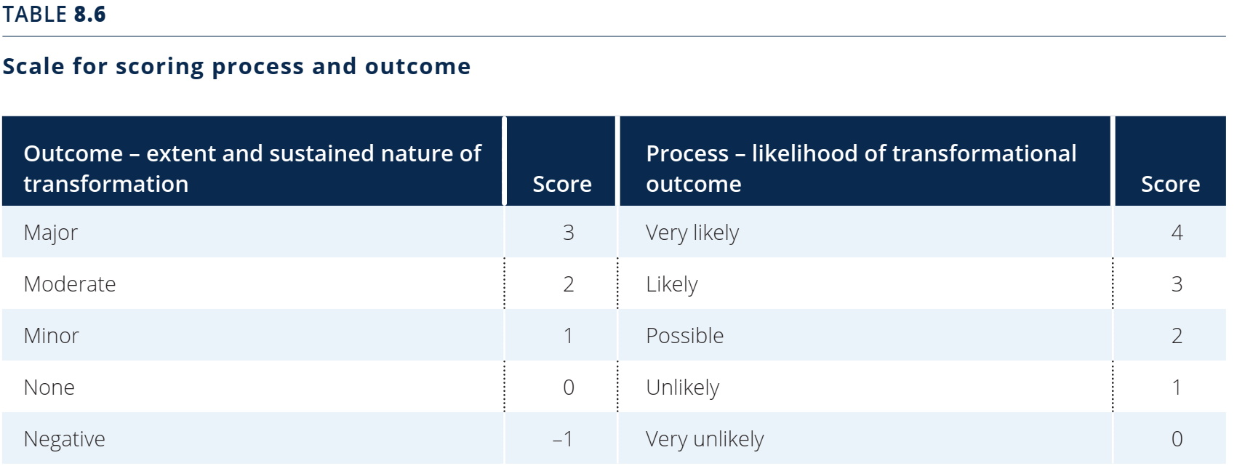
See Figure 8.2 in the Transformational Change Guidance for an example of how to illustrate the final result in the Transformational Impact Matrix
Outcome: Extent of transformation
Major
Moderate
Minor
None
Very likely
Likely
Very unlikely
Unlikely
Process: Likelihood of transformation
Possible
Negative
- The disaggregated scores at characteristic and category levels can be illustrated as shown in the Tonga energy efficiency case study (Figures 8.4 and 8.5), using the information on the scoring (and, if relevant, weighted scoring) of the characteristics and categories of processes and outcomes reported in the tables above. This is not required by the Guidance, but can help in showing your assessment results more clearly.
- The figures below can be edited to display your findings. Right-click on the figure, select “edit data” and edit the figures according to your findings.

Estimating impacts ex-post (Chapter 9)
- Collect data for selected process and outcome indicators in order to determine the extent of a transformation achieved
(Section 9.1)
- Assess and qualitatively score process and outcome characteristics in terms of their achievement of the envisioned transformation
(Section 9.2)
- For the method of aggregation, see explanations in previous section

Note: See Table 9.1 in the Transformational Change Guidance for the scoring scale of process and outcome characteristics
See Table 9.2 for an example of filling out the template for process characteristics
Category | Characteristic | Score | Rationale justifying the score | Indicators | Indicator value at starting situation  (start date) | Indicator value observed  (target date)
Technology | Research and development
Technology | Adoption
Technology | Scale up
Agents | Entrepreneurs
Agents | Coalition of advocates
Agents | Beneficiaries
Incentives | Economic and non-economic incentives
Incentives | Disincentives
Incentives | Institutions and regulations
Norms | Awareness
Norms | Behaviour
Norms | Social norms

Note: See Table 9.3 of the Transformational Change Guidance for an example of filling out the template for outcome characteristics
Category | Characteristic | Score | Rationale justifying the score | Indicators | Indicator value at starting situation  (start date) | Indicator value observed  (target date)
Scale of outcome - GHGs | Macro level
Scale of outcome - GHGs | Medium level
Scale of outcome - GHGs | Micro level
Scale of outcome – sustainable development | Macro level
Scale of outcome – sustainable development | Medium level
Scale of outcome – sustainable development | Micro level
Outcome sustained over time - GHGs | Long-term
Outcome sustained over time - GHGs | Medium term
Outcome sustained over time - GHGs | Short-term
Outcome sustained over time – sustainable development | Long-term
Outcome sustained over time – sustainable development | Medium term
Outcome sustained over time – sustainable development | Short-term

- Based on the disaggregated scores of process and outcome characteristics, score each process and outcome category and specify its relative importance
(Section 9.3.1)
- For the methodology, please refer to the previous section
Note: See Table 9.4 in the Transformational Change Guidance for an example of filling out the template
Category | Score | Rationale for scoring | Relative importance | Rationale for importance
Technology
Agents
Incentives
Norms

Note: See Table 9.5 in the Transformational Change Guidance for an example of filling out the template
Category | Score | Rationale for scoring
Scale of outcome-GHGs
Scale of outcome – sustainable development
Outcome sustained over time - GHGs
Outcome sustainable over time – sustainable development

- By aggregating values for the process and outcome categories to a final score, an assessment of the expected impact of the assessed policy/action/package can be derived.
- The overall assessment indicates the extent and sustained nature of the transformation achieved (outcome), and how this transformational outcome is realized (process)
(Section (9.3.2)

Note: See Table 9.6 in the Transformational Change for the scoring scale
See Figure 9.2 in the Transformational Change Guidance for an example of how to illustrate the final result in the Transformational Impact Matrix

Outcome: Extent of transformation
Major
Moderate
Minor
None
Very likely
Likely
Very unlikely
Unlikely
Process: Likelihood of transformation
Possible
Negative

Monitoring and Reporting (Part IV)
Monitoring performance over time (Chapter 10)
- Define the monitoring period and frequency. The monitoring period must be long enough to capture the full range of transformational impacts
(Section 10.1)
- Monitor each key performance indicator (selected in Section 7.1) over time in line with the monitoring plan.
(Section 10.3)

Note: See Table 10.1 in the Transformational Change Guidance for an example of filling out the template
Indicator | Type of data (quantitative/ qualitative) | Monitoring frequency and date of collection | Data source/ collection method | Responsible entity | Observed data (unit)

Reporting (Chapter 11)
- Provide information to all stakeholders affected by the policy/action/package assessed. Refer to the ICAT Stakeholder Participation Guide (Chapter 7) to learn more about providing information to stakeholders.

Decision-making and using results (Part V)

Learning, decision-making and interpreting results (Chapter 12)
- Describe insights gained from the assessment.
(Section 12.1)
- Explain how results are used to revise ongoing or future policies and actions.
(Section 12.2)

Information | Assessment information
Insights gained from the assessment and how results are used to revise ongoing or future policies and actions

